**Project Report**

**Group Members:**

1. Mohammed Ibrahim Shawon

(ID: 19-40767-2)

1. Islam, Ezazul

(ID: 18-38362-2)

1. SHAON, INDROJIT DHE

(ID: 18-38674-3)

1. SAMIHA HOSSAIN

(ID: 20-42435-1)

# Introduction

Our project is mainly based on a village scenario. We wanted to demonstrate a look of a village in a simple manner. The scenario contains different types of objects such as houses, trees, windmill, hills, river, boats, Christmas tree, sun and etc. The scenario also changes as time progress with three different effects for example sunny day, rainy day and night view. We wanted to use all of our knowledge gained through the course in our project. The project is based on opengl and glut we used mostly the primitive functions and algorithms to complete the project.

**DIAGRAM**

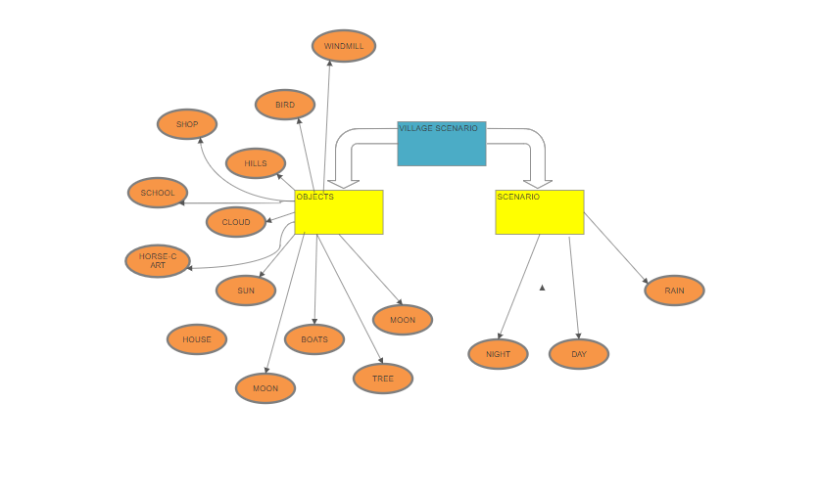

# Project Background

There are many related tasks are in GOOGLE, YouTube, and other platforms.

# Objective of the Project

Our project is scenario-based. We can see many moving and unmoving objects in the scenario. The moving objects are ships, birds, clouds, sun, moon, horse-cart, windmill. And the unmoving objects are the hills, Shop, School, small village home, trees, Christmas tree and so on.

# System Implementation method

To build our project we have used OpenGL from the Code-blocks software. Also, we used some RGB colors from the w3School color pickers to create our project. It helps to create our project more attractive. Here is some of the Screenshots of the project which we implement by using Code-Blocks.

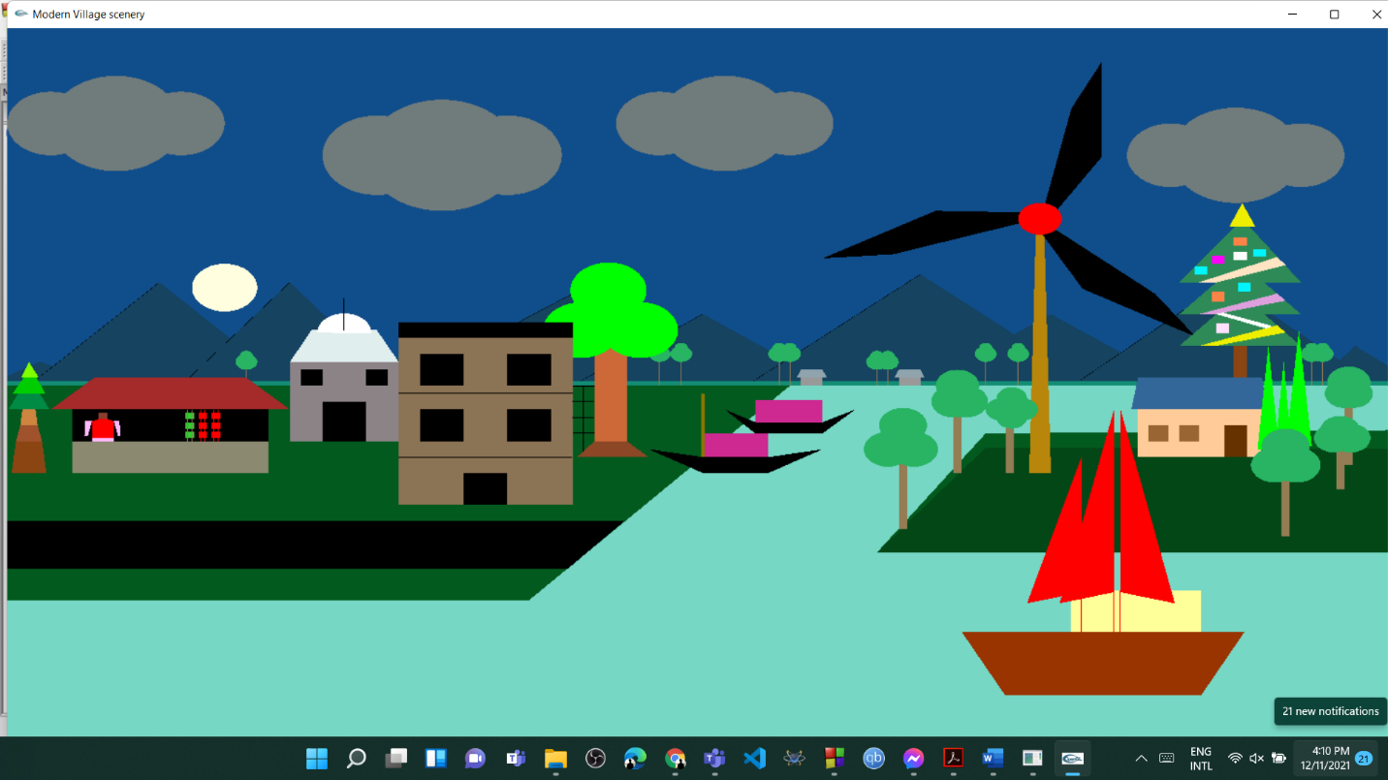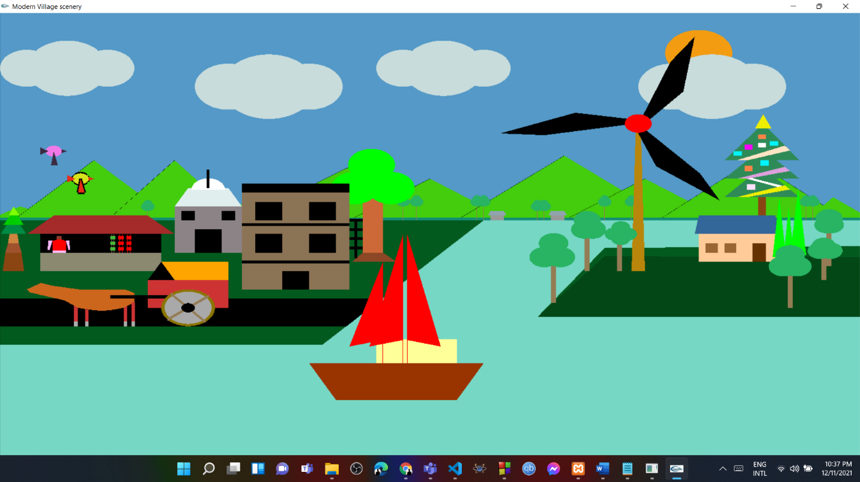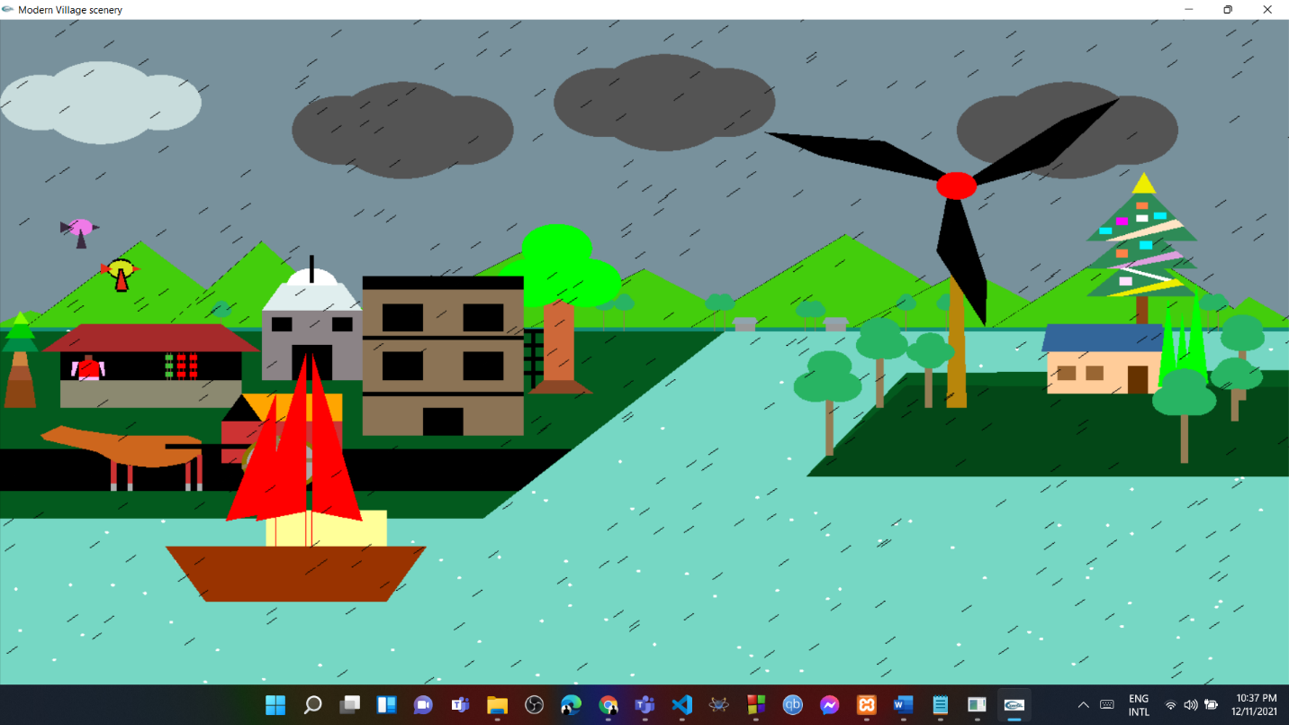

## Significant of the project

As our project is scenario-based, from our project people can learn how to build OpenGL projects and they will get the knowledge to build a project similar to us. And also, people can get the knowledge of how a city should be built and how it should be organized. If they can build something similar like this people will get attracted to visit this kind of places.

### Conclusion

From this type of scenario, we can attract many tourists to visit these kinds of places and also some of the projects can be implemented for educational purposes.